PREFACE: Azure Permission Required to Proceed:
- Application Administrator
or
- Application Developer Account

- Go to:
https://portal.azure.com
- In the list of Azure services, click on:
Microsoft Entra ID
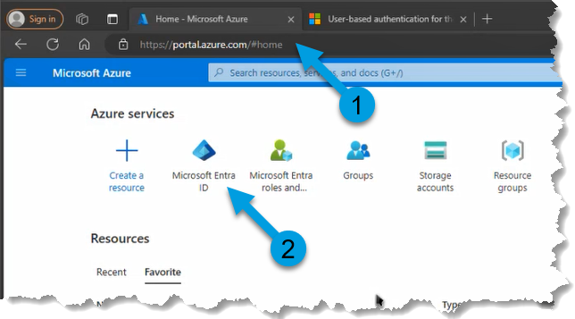

- Click:
  - Manage>App Registrations
- Click:
  - New Registration
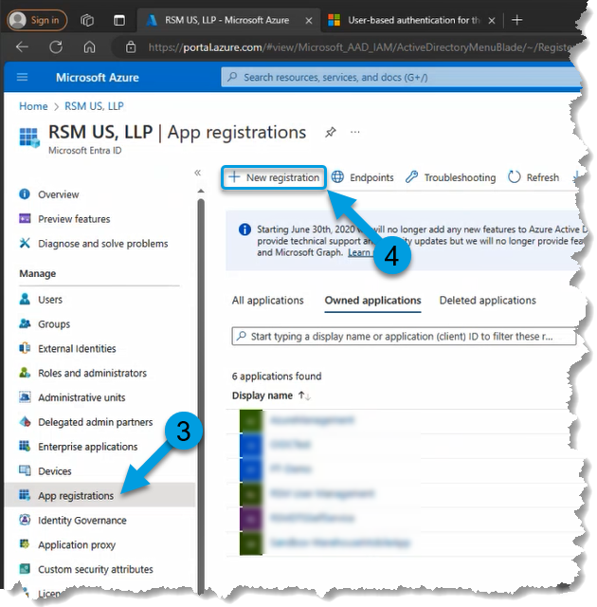

- Enter Name:
  - Industrials Mobile Device
- Click:
  - Register
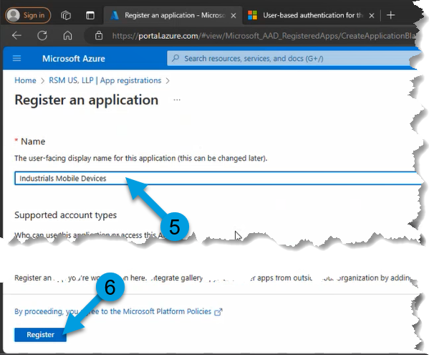

OPTIONAL: Grab information for later input to mobile device:
  - Application (client) ID
  - Directory (tenant) ID

- Click:
  - Manage>Authentication
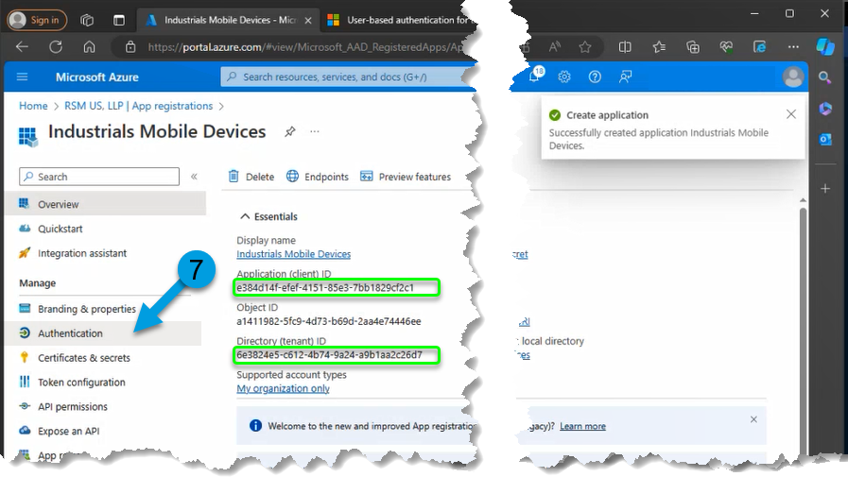

- Change Slider:
  - Allow public client flows: YES
- Click:
  - Add a platform
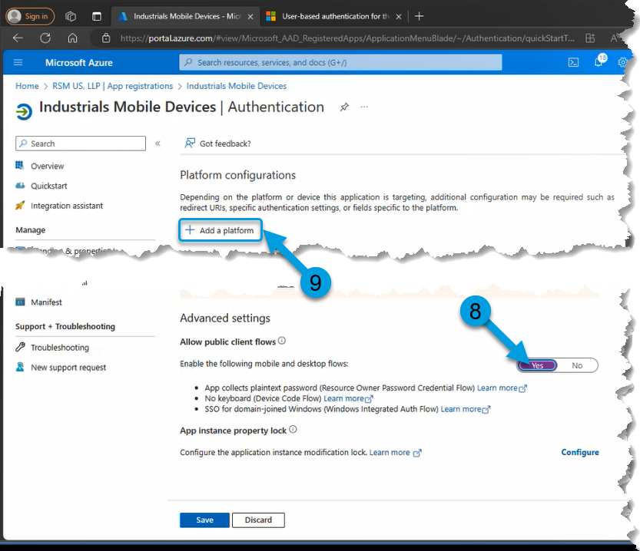

- Select Desired Platform
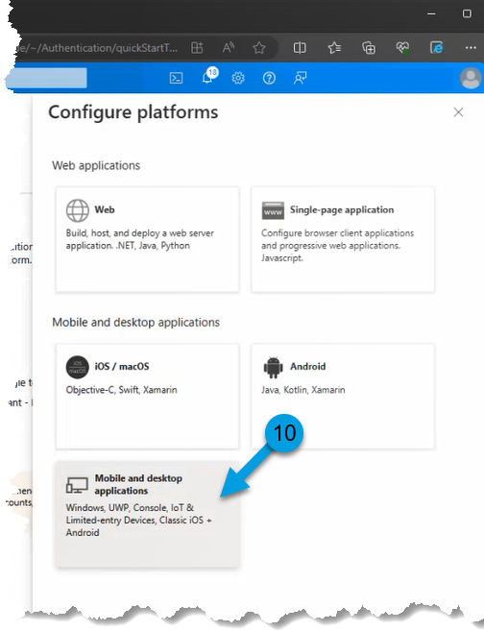

- Locate and Copy the custom redirect URL from the Microsoft learn article:
  - User-based authentication for the Warehouse Management mobile app - Supply Chain Management | Dynamics 365 | Microsoft Learn
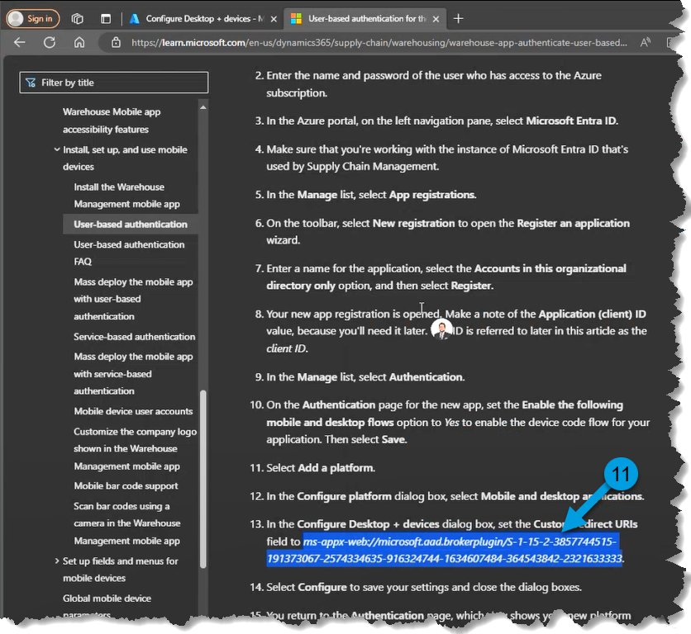

- Paste the URL from the previous step.
- Click:
  - Configure
- Click:
  - Save
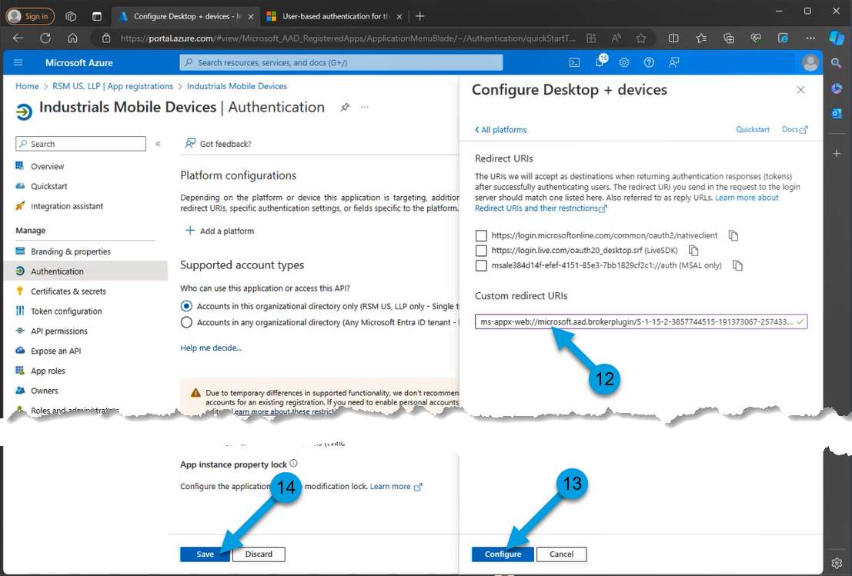

- Click:
  - Manage>API Permissions
- Click:
  - Add a permission
- Click:
  - Dynamics ERP
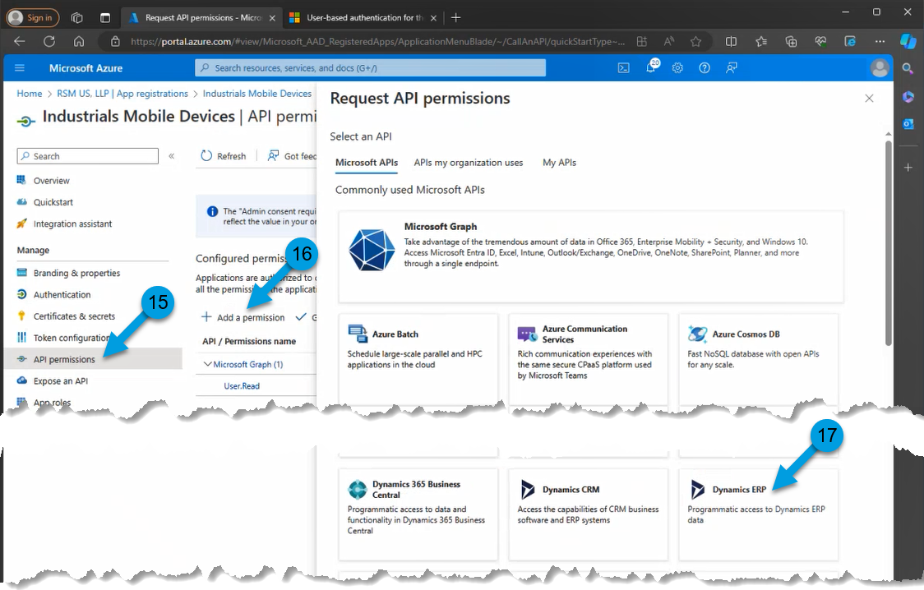

- Click:
  - Delegated Permissions
- Select:
  - CustomService.FullAccess
- Click:
  - Add permissions
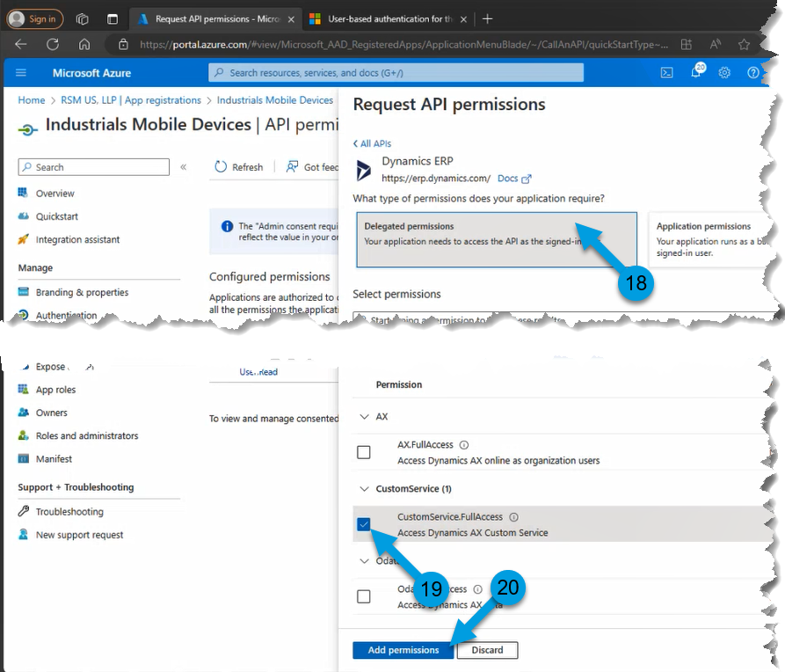

- Click:
  - Your Tennant Name
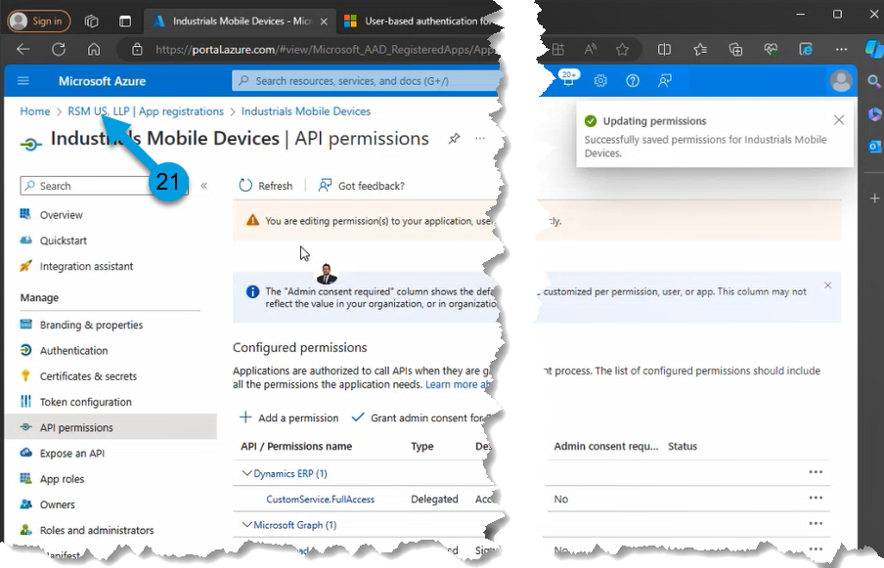

- Click:
  - Manage>Enterprise applications
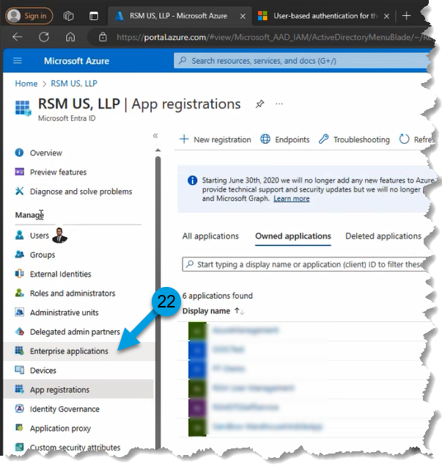

- Search for the application created in step 5-6.
- Click on the application name.
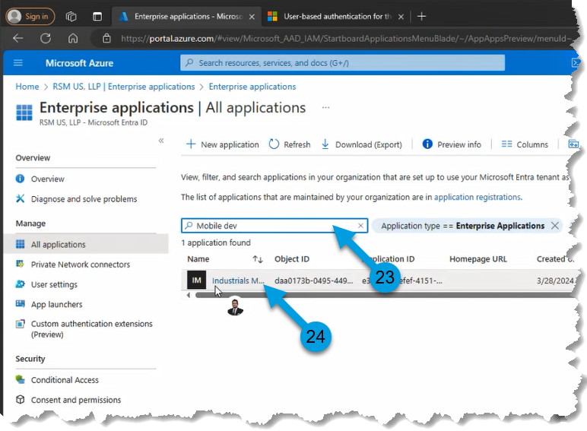

- Click:
  - Manage>Properties
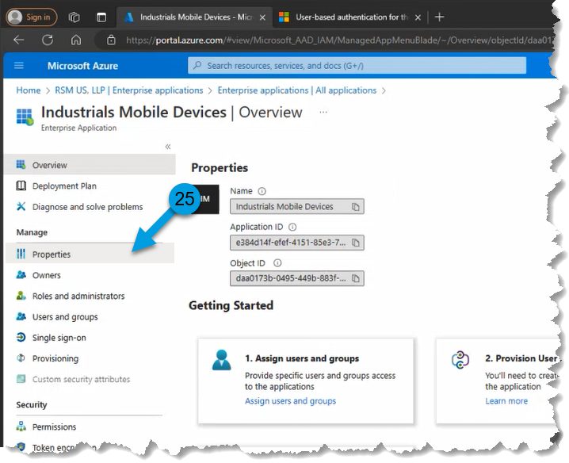

- Change Slider:
  - Assignment required?: YES
- Change Slider:
  - Visible to users?: YES
- Click:
  - Save.
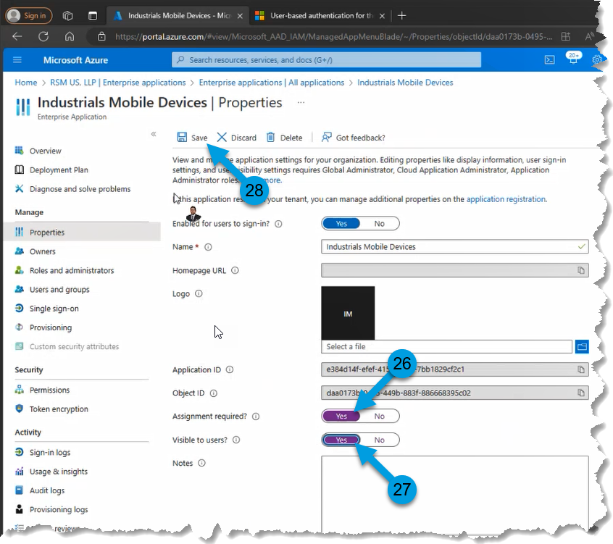

- Click:
  - Manage>Users and groups
- Click:
  - Add user/group
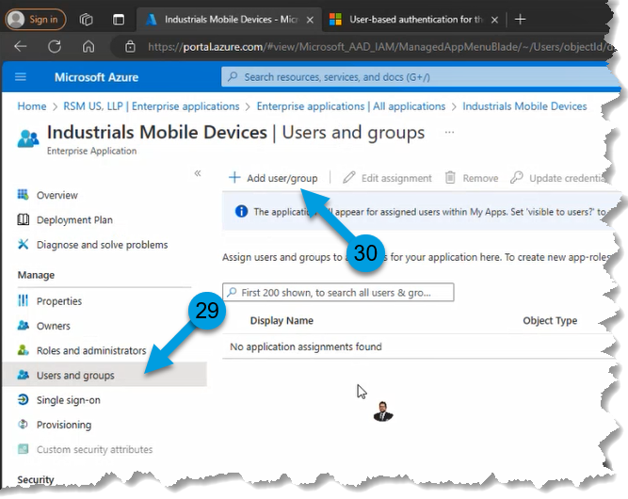

- Click:
  - Non Selected
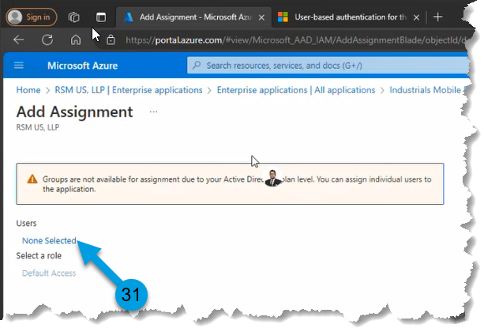

- Search for a users or groups.
- Select the users to add.
- Click:
  - Select
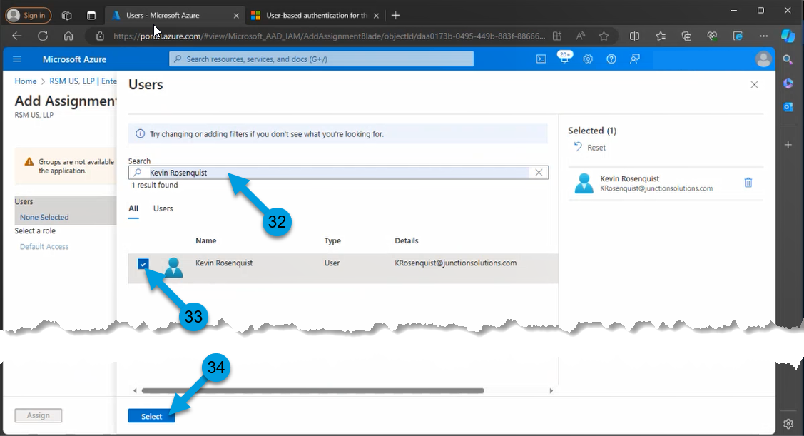

- Click:
  - Assign
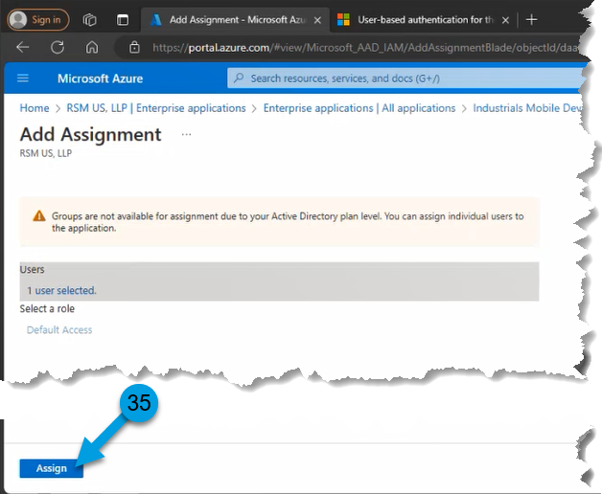

- Click:
  - Grant admin consent for [Tennant]
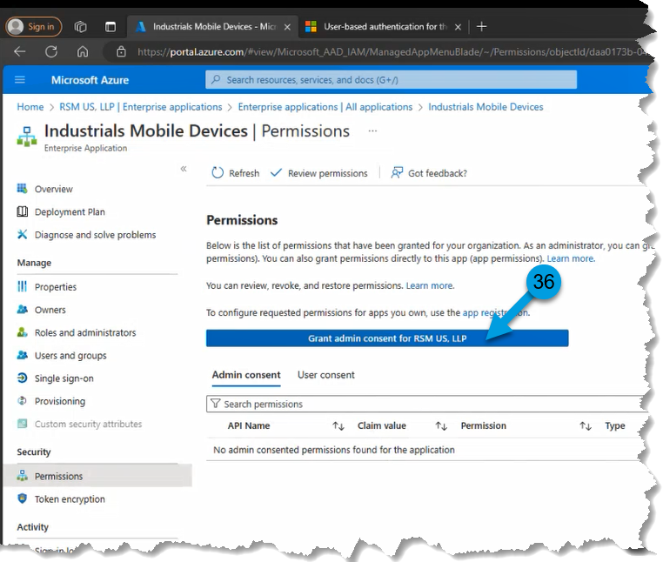

- Select the System Administrator Account Login
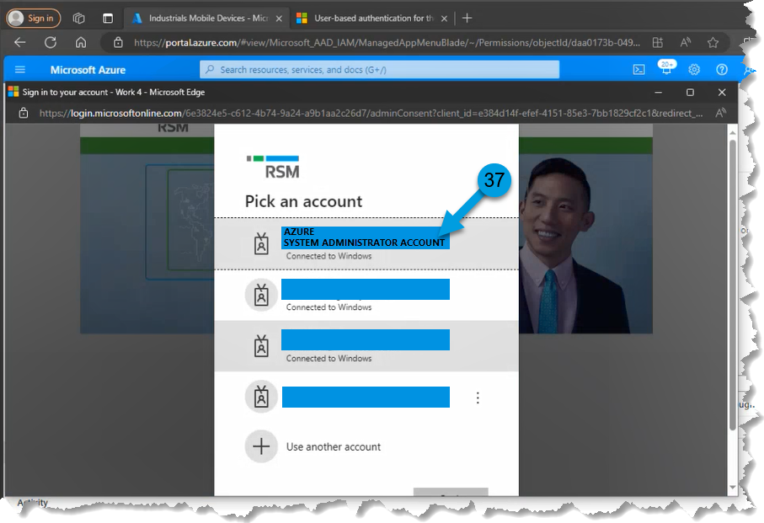

- Click:
  - Accept
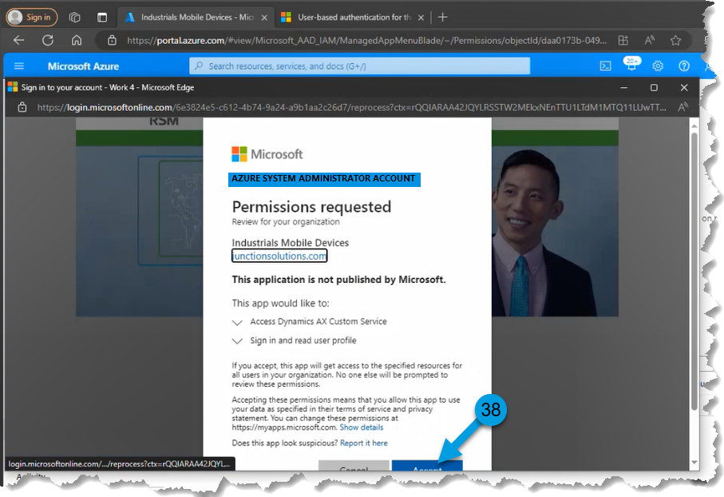

- Click:
  - Refresh
- Confirm API now has Admin consent.
